Year 5 English Homework - Term 1: Week 6 16/10/26 (Due 21/10/26)
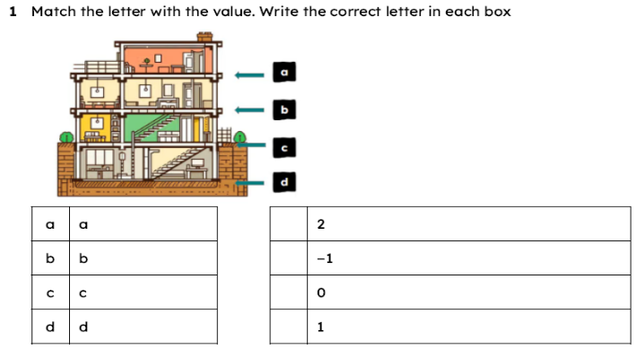
Review: How can I use inverted commas to indicate direct speech?
Put the missing inverted commas in each sentence.
- The girl said, I’m very tired of eating all this chocolate.
- I’m very tired of eating all this chocolate, the girl said.
Main Focus: How can I correctly punctuate fronted adverbials?
Look at the sentences below. Add the missing comma after the fronted adverbial
- After a while the mermaid realised her Prince was not returning and gave up.
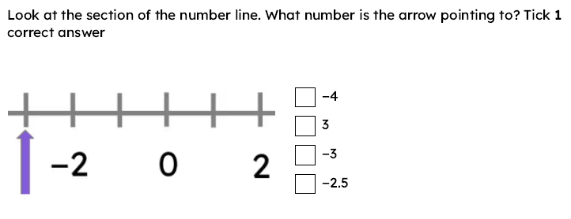
- Before long the Princess had formulated a plan to escape from her towery prison.
- As the sun was setting all the fairies buzzed and fluttered around the palace, preparing for the ball.
- Twice a year a group of young men from the village would venture into the forest in search of the great fabled beast.
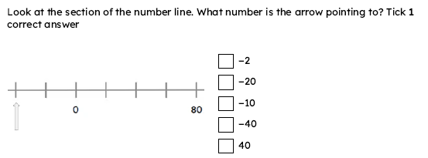
- Above the clouds the magical palace floated.
- Between the sea and the sky there is a legendary place where all the magic in the world can be found.
- Behind the waterfall a beautiful cave was hidden.
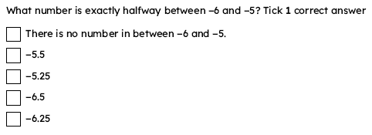
- In the distance there were unicorns furiously galloping towards the beach.
- As quick as a flash the wizard tapped his hat with his wand and disappeared.
- Positively trembling with excitement the little girl reached out her hand and gripped the door handle.
Year 5 Maths Homework - Term 1: Week 6 16/10/26 (Due 21/10/26)
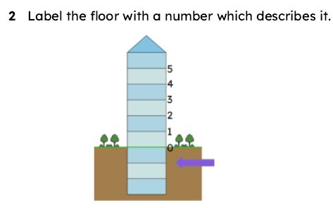
Review: How can I read and write negative numbers?
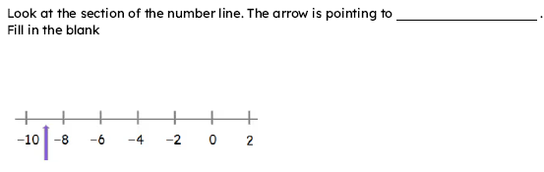
Main focus: How can I identify and place negative numbers on a number line?

